LINQ E-commerce Store

Abhinav Satish Shah - 6224423  
Manthankumar Makwana - 6210600  
Mohnish Sethi - 6380387  
Niketh Jain - 6405568  
Shrey Desai - 6462928

Date: Feb 15th, 2013

# 1. Personas, Actors, and Stakeholders

## Persona:

One of the main users of the LinqCommerce software are the customers using this e-commerce store. For instance, here we have the case of John Smith who is a businessman and hardly gets time to perform common chores and prefers getting these activities done online.

Using the e-commerce application he could buy products of his interest which are related to different categories and departments in the store. He also prefers to view products that are on discount or on promotion. In addition to this, he likes to finalize the products to purchase based on the past reviews / comments. These functionalities drive John Smith to use LinqCommerce for e-shopping.

## Stakeholders and Actors:

**Customers:** Customers are the primary actors that use the LinqCommerce application. They are the ones who use this application to shop products online. They can register themselves online and login to the application to select the products they want to purchase. They can add these products to the cart and manipulate the quantity of these products on the fly. After the payment is processed, they can review the products, helping other customers to purchase products using this application.

**Administrator:** Administrator forms the heart of LinqCommerce application. An administrator can manage the shopping cart, to empty those carts that the customers never checked out. He/she is able to manage product catalogs by adding discount coupons to different products, add new products and edit existing products in the system. He also has the authority to manage orders and inventory, where he can add / remove / edit suppliers’ information and keep a track of different product levels.

**Payment Gateways:** LinqCommerce is integrated with PayPal Website Payments Standard and Google Checkout which are used to process payments. These two payment gateways send customers to a 3rd party site to accept payment, then notify the customers that payment has been received. LinqCommerce sends these payment systems, an order ID, an order name, a quantity of 1 (there is only 1 order), and a total for the order. Once the order is complete, both systems use a payment notification system to contact LinqCommerce. This system also supports other payment gateways like Authorize.NET AIM, and PayPal PayFlow Pro. These are the gateways that allows the customers to accept credit cards directly on the website.

**Suppliers:** Suppliers are secondary actors who supply the products they want to sell and publish on the site. These suppliers are managed by the administrator. They send the request to the administrator with their personal information and the detailed information related to the products that they want to sell. Administrator in turn, with the support of the suppliers will be able to add the suppliers’ information and the products which will be accessible to the customers.

# 2. Informal Use Case

## Queue Card length Use Case

Customer Goal Use-cases

|  |
| --- |
| **Customer Registration** |
| 1. Customer enters profile information to get registered as an authorized user. |
| 1. While creating a profile, LinqCommerce checks whether the customer has entered all the mandatory fields and has entered all input data in valid format. |

|  |
| --- |
| **Manage Profile** |
| 1. Customer opens relevant form to update his profile. |
| 1. System provides the form filled with the customer details he wants to edit |
| 1. Customer can update the information in his profile and save it to the system. |

|  |
| --- |
| **Maintain Billing Information** |
| 1. Customer enters billing information to successfully purchase the products |
| 1. System checks whether the customer has entered all the mandatory fields and has entered all input data in valid format. |

|  |
| --- |
| **Maintain Wish list** |
| 1. Customer adds/removes products based on his needs on the wish list. |
| 1. The system approves customer’s requests. |
| 1. The customer can also add the products to the shopping cart from the wish list. |

|  |
| --- |
| **Search Products** |
| 1. Customer enters the product name he wants to view / purchase in the search bar. |
| 1. The system filters the product from the list of products in the database and the result is shown to the customer. |

|  |
| --- |
| **Buy Products** |
| 1. Once the customer adds the desired products to the cart, he shall request to checkout. |
| 1. The system acknowledges the request and redirects the customer to a secure payment gateway. |
| 1. The customer enters the payment details and the billing/shipping information. |
| 1. Once the payment is processed, the customer will be notified. |

Administrator Goal Use-cases

|  |
| --- |
| **Manage Shopping Cart** |
| 1. The customer adds the desired products to the cart. |
| 1. The customer shall log out of the application without wishing to checkout products. |
| 1. The administrator deletes the shopping cart after certain point of time. |

|  |
| --- |
| **Manage Product Catalog** |
| 1. The administrator adds discount coupons to the products in the inventory. |
| 1. The administrator adds new products to the inventory. |
| 1. The administrator edits the details of existing products in the inventory. |

|  |
| --- |
| **Manage Orders** |
| 1. The administrator keeps track of the orders placed by different customers. |
| 1. The administrator approves the order. |
| 1. The administrator can see details of each order. |

|  |
| --- |
| **Manage Inventory** |
| 1. The administrator keeps a track of product levels in the inventory. |
| 1. The administrator adds new product order or edit existing product order in the application. |
| 1. The administrator enters the details of the product. |
| 1. The administrator adds new suppliers or edit existing suppliers. |
| 1. The administrator enters the details of the suppliers. |

# 3. UML Domain Diagram

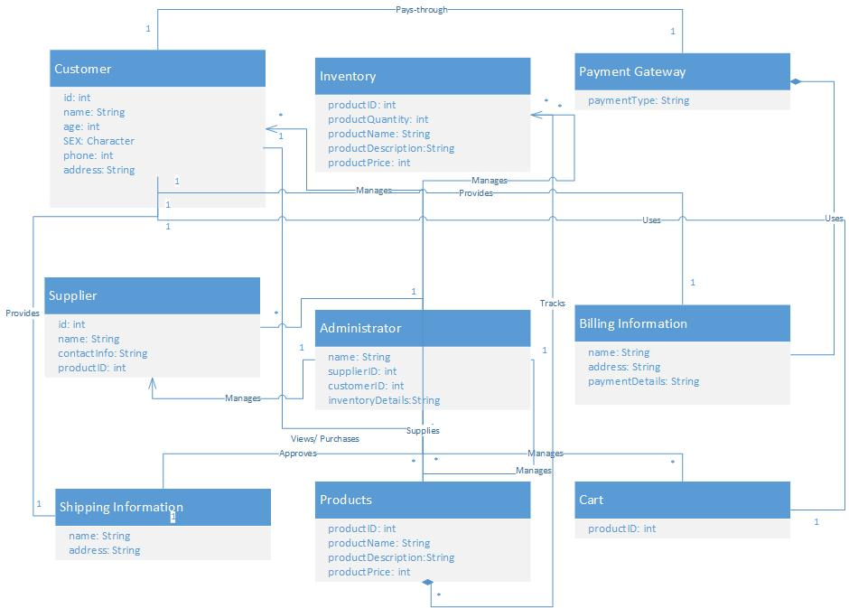

Figure 1: UML Domain Diagram